Demonstrated that you can read and write to the primary database – us-east-1a

DATABASE|UDACITY1|PRIMARY
Create the Table
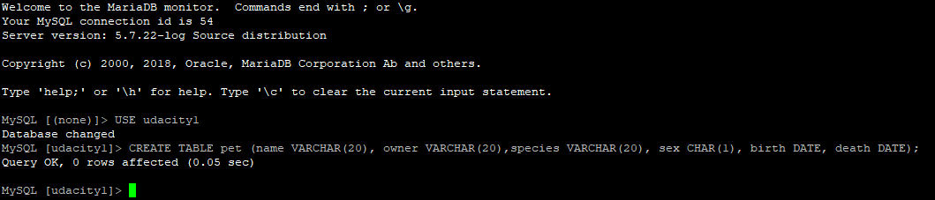

CREATING THE TABLE
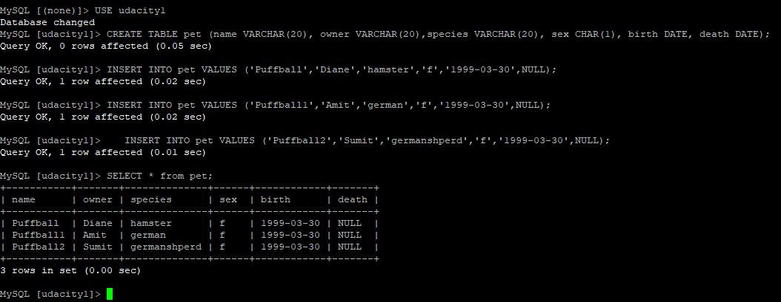

DATABASE|UDACITY1 – CLOUDWATCH Metrix.

